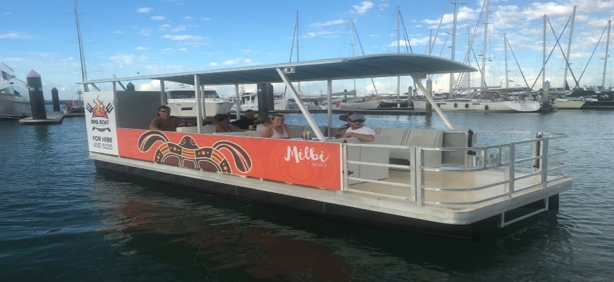
This Photo by Unknown Author is licensed under CC BY
When: August 23, 2022
Meet at Day Marker 2 Outside Ocean Pines at 12:00 PM
Where: Fish Tales
2107 Herring Way, Ocean City,Md 21842
Contact: Jerry Leuters
dorado1045@yahoo.com
240-427-8929

Hope to See You There!

